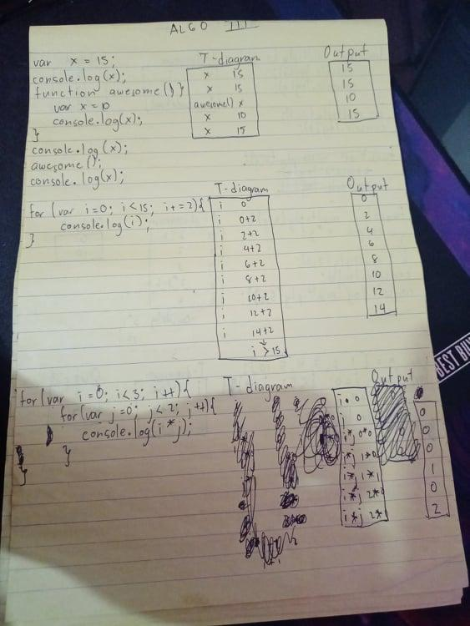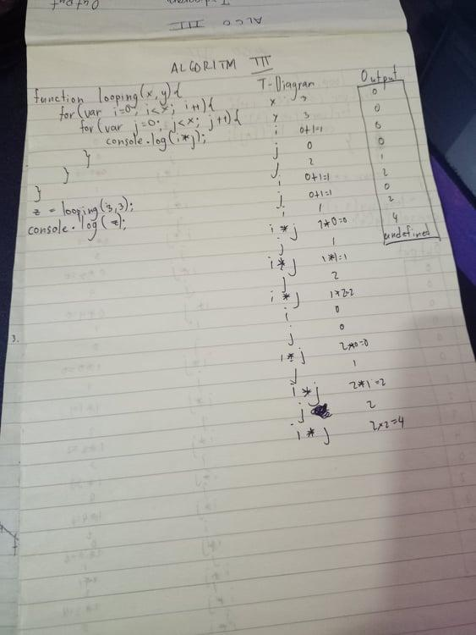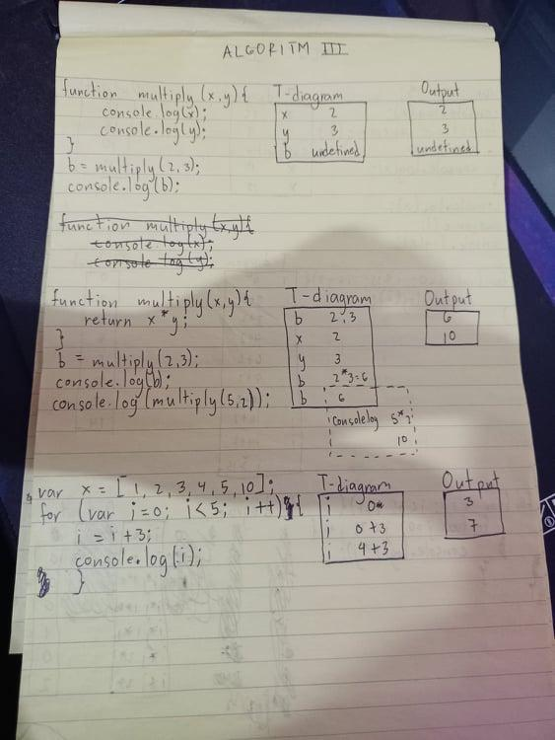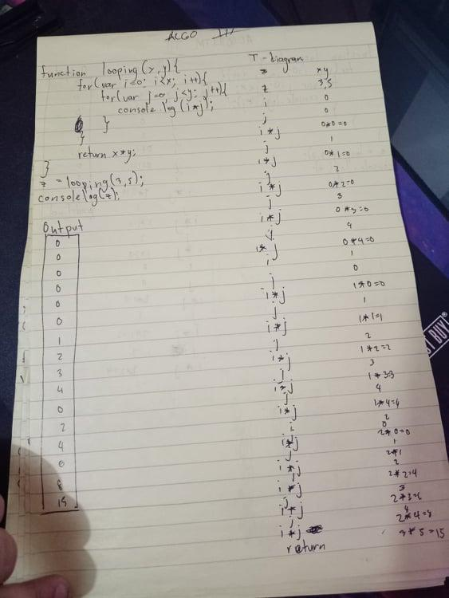

PART 2:

function printUpTo(x) {

// your code here

for (var i = 1; i <= 1000; i++) {

console.log(i);

}

if (x < 0) {

return false;

}

}

printUpTo(1000); // should print all the integers from 1 to 1000

y = printUpTo(-10); // should return false

console.log(y); // should print false

function printSum(x) {

var sum = 0;

//your code here

for (var i = 0; i <= x; i++) {

sum += i;

console.log(i);

}

return sum;

}

y = printSum(255); // should print all the integers from 0 to 255 and with each integer print the sum so far.

console.log(y); // should print 32640

function printSumArray(x) {

var sum = 0;

for (var i = 0; i < x.length; i++) {

//your code here

sum += x[i];

}

return sum;

}

console.log(printSumArray([1, 2, 3])); // should log 6